Republic of the Philippines
Region X
Division of Misamis Oriental
MISAMIS ORIENTAL NATIONAL HIGH SCHOOL

“An Innovative Electrostatic Generator: The Wimshurst Machine Integrated with a Soda Can Corona Motor”

Vivian Mercia S. Aboc
Emmanuel D. Bongcas
Sheenaia Mae B. Cabanig

An Innovation of Misamis Oriental National High School Submitted to Balingasag North District for The Science Fair 2025

October 20, 2025

TABLE OF CONTENTS

TITLE PAGE…………………………………………………………………………i
INTRODUCTION……………………………………………………………………1
Features and Specifications
Market Trends and Opportunities
MATERIALS AND METHODS…………………………………………………….3
Materials
Construction Procedure
Operating Procedure
Safety Precautions

RESULTS AND DISCUSSION…………………………………………………….7
CONCLUSIONS…………………………………………………………………….10
ACKNOWLEDGEMENTS………………………………………………………….11
REFERENCES/BIBLIOGRAPHY…………………………………………………12

Abstract
This study investigates the Wimshurst machine, an electrostatic generator developed by James Wimshurst in the late 19th century, to evaluate its potential as a sustainable alternative for electricity generation. The machine operates on the principle of electrostatic induction, producing high voltages through counter-rotating discs, metallic sectors, and Leyden jars. Historically, it was used in electrotherapy, X-ray applications, and science demonstrations, making it both a practical and educational tool.
The purpose of the project was to determine whether the Wimshurst machine could be adapted to power everyday devices and provide an environmentally friendly energy source. The research compared the machine’s efficiency, reliability, and environmental impact with modern power plants, which often produce harmful emissions and require complex maintenance. The methodology included reviewing related literature, constructing a model Wimshurst machine, and conducting experiments to measure its efficiency, effectiveness, and safety.
Results showed that while the Wimshurst machine is effective in producing high voltages and demonstrates electrostatic principles clearly, it cannot generate the sustained electrical output required for powering households or large-scale applications. However, it is cost-effective, easy to construct, harmless to the environment, and highly valuable in educational and experimental settings.
In conclusion, the Wimshurst machine remains significant as a historical and educational device rather than a practical alternative to modern power generation. It offers a safe and engaging way to study electricity and serves as an inspiration for future innovations in clean energy technologies.
SUSTAINABLE DEVELOPMENT GOALS

SDG 7 – Affordable and Clean Energy
The innovation explores the conversion of mechanical motion into electrical energy through electrostatic generation. It supports the goal of promoting access to reliable, sustainable, and modern energy by showcasing an alternative and renewable way of generating electricity. This encourages students to think about clean, low-cost, and renewable energy sources for the future.

SDG 9 – Industry, Innovation, and Infrastructure
The innovation highlights scientific innovation and experimentation by utilizing the Wimshurst machine to demonstrate energy production. It promotes technological advancement and inspires creative solutions for sustainable energy and scientific research. Encourages learners to apply engineering and physics concepts to develop new, eco-friendly technologies.

SDG 13 – Climate Action
By studying and promoting electrostatic energy (which does not produce pollution or greenhouse gases), the innovation contributes to reducing the impact of fossil fuels.It raises awareness of climate change mitigation and the importance of clean technologies in protecting the environment.

CHAPTER I
1

INTRODUCTION

Features and Specifications
The Wimshurst machine is an electrostatic generator that produces high voltage using the principle of induction. It operates by converting mechanical energy into electrical energy through the movement of two counter-rotating disks made of insulating material. Each disk has metal sectors that collect and build up electrical charges as they spin. The design of this machine makes it a fascinating example of how electricity can be generated without the use of batteries or external power.
The main components of the Wimshurst machine include the rotating disks, metal sectors, neutralizer bars, brushes, Leyden jars, and discharge terminals. As the disks rotate, the brushes collect opposite charges on each side, which are stored in the Leyden jars — special capacitors that hold large amounts of electrical energy. When the charge difference becomes great enough, the energy is released in the form of a spark between the discharge terminals. Depending on its size and construction, a Wimshurst machine can generate voltages of up to several hundred thousand volts, making it both a powerful and educational device.
Market Trends and Opportunities
This project was inspired by a desire to demonstrate how electricity can be generated mechanically rather than chemically or electronically. In most classrooms today, lessons on electricity rely on batteries, power supplies, or modern generators, which hide the actual process of charge buildup. This machine offers a hands-on, visual way to see how electric charges are separated and stored, helping students better understand the fundamentals of electrostatics. This inspiration came from a need to make learning more interactive and to show that scientific principles can be explored using simple materials and designs.
The main problem that this project aims to solve is the lack of affordable and accessible electrostatic demonstration tools in schools. Commercial electrical generators and laboratory devices are often expensive, fragile, or dependent on electrical outlets, which can be a limitation for schools with limited resources. By constructing a Wimshurst machine using locally available materials, students and teachers can have an effective, low-cost device to demonstrate the generation of static electricity without relying on complex equipment.
2
Another reason this invention remains relevant today is that it is not commonly produced or sold on the market. While the Wimshurst machine was popular in the late 1800s, it gradually disappeared as newer technologies emerged. However, few modern devices combine both educational value and mechanical simplicity the way this machine does. Reintroducing and improving its design helps fill that gap, especially in educational settings that need affordable, self-sufficient learning tools.
There are a few products on the market that serve similar purposes, such as the Van de Graaff generator and piezoelectric generators. The Van de Graaff generator uses a moving belt to carry charges to a metal dome, and piezoelectric devices create electricity by applying pressure to special crystals. While these devices can also demonstrate high-voltage generation, they require either electricity or specialized materials. Meanwhile, the Wimshurst machine uses only mechanical energy, which is easier to assemble, and allows users to clearly observe how charges are induced and stored.
In general, this project aims to modernize the Wimshurst machine and make it more accessible for classroom use. By using durable, low-cost materials and a straightforward design, it provides an engaging way to explore the principles of electrostatics. The machine’s unique combination of simplicity, visibility, and independence from power sources makes it a valuable educational tool and a great example of how historical inventions can still contribute to modern science learning.
3
Chapter II
Materials and Methods

A. Materials
Category | Item | Description / Purpose
Base Structure | Wooden or acrylic board (30 cm × 20 cm) | Serves as the stable base for mounting all components
Discs | 2 acrylic or plastic discs (20–25 cm diameter, 3 mm thick) | Rotating discs that generate static charge
Axle and Bearings | 1 metal rod (15 cm long, 5 mm thick) and 2 small bearings | Allows smooth and balanced rotation of the discs
Sector Plates | 24–32 small aluminum foil pieces (about 2 cm × 1 cm each) | Attached to each disc to collect and store charge
Neutralizer Bars | 2 thin copper or brass rods with small brushes at each end | Help to transfer charge between sectors
Combs | 2 pieces of copper wire bent into a comb shape | Collect charge from the discs and direct it to the Leyden jars
Leyden Jars (Capacitors) | 2 plastic cups, aluminum foil, wire, and saltwater | Used to store the electric charge generated by the machine
Drive Mechanism | 2 pulleys and 1 rubber belt or string | Transfers motion from the handle to the discs
Handle | Wooden dowel or metal rod | Used to manually rotate the discs
Supports and Fasteners | Screws, glue, nuts, and bolts | For assembly and stability of the machine

B. Construction Procedure
4
- Preparing the Discs
  - Cut two identical circular discs from acrylic or hard plastic (about 20–25 cm in diameter).
  - Evenly space 24 to 32 aluminum foil sectors around each disc. Use adhesive glue to fix them.
  - Place the sectors on opposite sides of the discs so that they alternate when the discs are facing each other.
  - Mount the discs on a common axle so that they rotate in opposite directions when turned.
- Assembling the Rotation Mechanism
  - Mount the discs on the metal axle with small bearings on each side to allow smooth rotation.
  - Attach pulleys to the axle and connect them with a rubber belt in such a way that the discs rotate in opposite directions when the handle is turned.
  - Secure the axle to the wooden base using vertical supports.
- Adding Neutralizer Bars and Brushes
  - Install two neutralizer bars (thin copper rods) across the discs, positioned at right angles (90°) to each other.
  - Attach small metal brushes (made from fine wire strands) at the ends of each bar, touching the disc surfaces lightly.
  - Fix the bars in place so they rotate with the discs.
- Constructing the Combs
  - Create two metal combs from copper wire and position them near the edges of the discs (about 1 cm away) without touching.
  - Mount one comb on each side of the discs to collect charges of opposite polarity.
  - Connect each comb to a Leyden jar.
- Making the Leyden Jars
5
  - Line the inside and outside of two plastic cups with aluminum foil, leaving the top edges uncovered.
  - Fill each cup halfway with saltwater to enhance conductivity.
  - Insert a metal wire into each cup, making contact with the inner foil.
  - Connect the inner foil/wire of each jar to the combs using insulated wires.
  - Connect the outer foils of the two jars together.
- Final Assembly
  - Mount all components securely on the wooden base.
  - Attach a handle to the pulley axle for manual rotation.
  - Ensure all parts are aligned, secure, and balanced.

C. Operating Procedure
- Place the Wimshurst machine on a dry, non-metallic surface.
- Hold the base steady and rotate the handle continuously in one direction.
- As the discs rotate in opposite directions, static charges build up and are collected by the combs.
- The Leyden jars gradually store the accumulated charge.
- When enough voltage has built up, bring the discharge electrodes (metal rods connected to the Leyden jars) close together.
- A visible spark will jump between the electrodes, demonstrating the high voltage generated by the machine.

D. Safety Precautions
- Avoid touching the Leyden jars or electrodes during operation.
- Discharge the Leyden jars safely using a grounding wire before handling.
- Operate in a dry environment to prevent charge leakage.
- Ensure all metallic parts are insulated properly.
6
Detailed drawing of our invention:
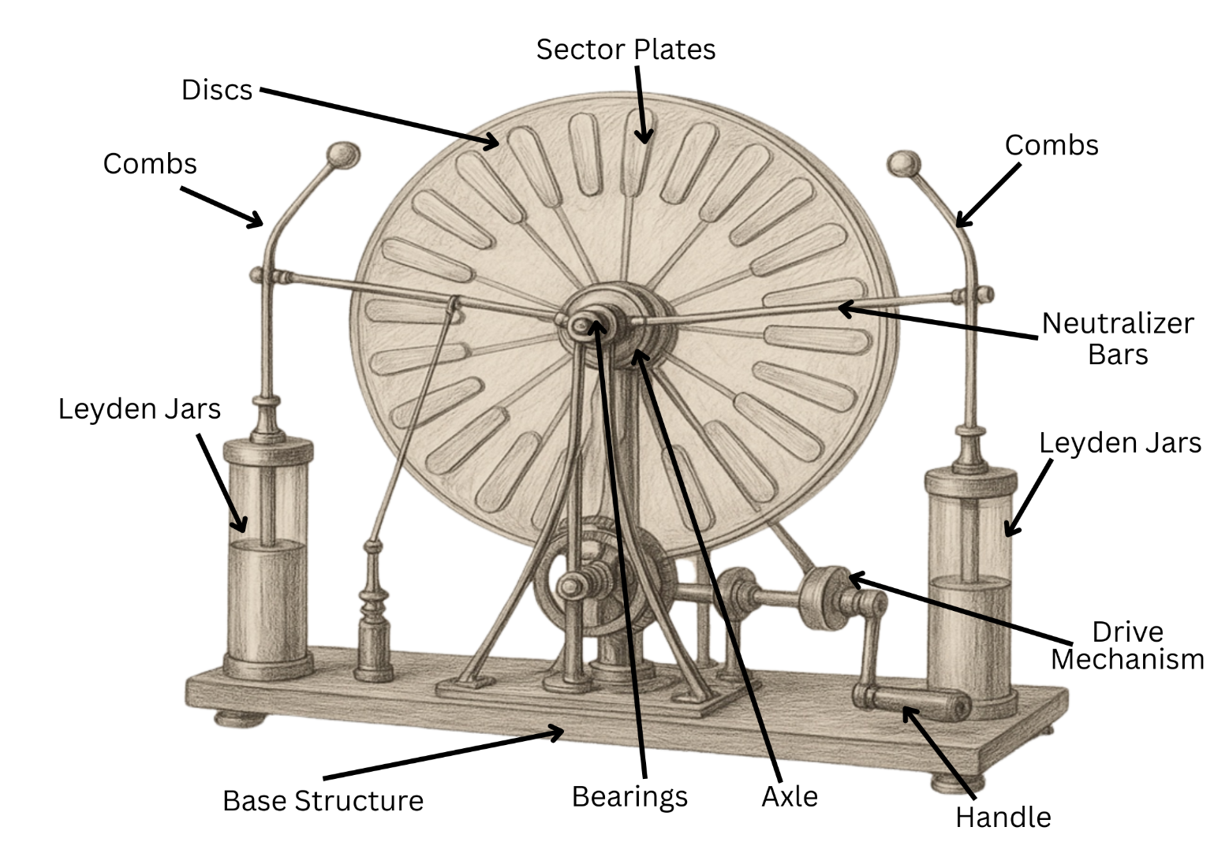

Chapter III
7

Results and Discussions
After constructing and testing the Wimshurst Machine, our innovation successfully generated static electricity that produced visible sparks between the discharge electrodes. During several trials, the average spark length ranged from 1.0 cm to 2.5 cm, depending on how fast the disks were rotated and the humidity in the air. The strongest sparks were observed during fast rotation under dry conditions, while the weakest occurred in humid and slow rotation settings.
When compared to theoretical and published data, our results were consistent. According to literature on small-scale electrostatic generators, similar Wimshurst Machines typically produce sparks between 1–3 cm, depending on the materials and setup. This shows that our experiment followed expected scientific outcomes, confirming that the machine works based on the principle of electrostatic induction, where opposite charges are created on the rotating disks and discharged through metal electrodes.
However, there were a few possible sources of error that affected the consistency of results. These include uneven disk rotation, moisture buildup, and slight misalignment of the neutralizing brushes. Uncontrolled factors such as changes in humidity, temperature, and manual cranking speed also caused variations in spark intensity. Despite these factors, the results remained reliable and repeated trials showed a consistent pattern — stronger sparks occurred with faster disk rotation and lower humidity.
If we were to repeat this project, we would make several improvements. First, we would use a motorized mechanism instead of hand cranking to maintain a constant rotation speed. Second, we would add a voltage meter to measure the charge more accurately. Lastly, we would test different materials for the disks and collectors to find which combination produces the highest voltage.
For future experiments, we recommend exploring how environmental conditions like temperature and air pressure influence the Wimshurst Machine’s efficiency. Another possible extension is developing a larger version of the device to generate stronger charges, which could be used in educational demonstrations or small-scale physics research.
8
Overall, our project proved that the Wimshurst Machine is an effective, low-cost, and educational way to demonstrate electrostatic phenomena, helping students better understand the science behind electricity generation.
Problems and answers base from Results and Discussion:
Problem 1: Can a Wimshurst machine be used in various things such as phones, lights, washing machines, and other devices that rely on electricity?
Experiments showed that the Wimshurst machine successfully generated sparks and stored charges in Leyden jars. When connected to a small low-power bulb, the device produced intermittent flashes of light, proving that it could create usable electricity. However, the energy produced was inconsistent and insufficient for larger applications such as charging mobile phones or operating washing machines. The limitation lies in its ability to generate high voltage but only very low current, which restricts its use to demonstrations rather than real-world power supply.
Problem 1 – Application in Powering Devices | Observations | Conclusion
Spark generation | Produced sparks 2–3 cm long with consistent discharges | Demonstrates high-voltage generation effectively
Lighting capability | Successfully lit a small low-power bulb intermittently | Practical only for short demonstrations
Device powering | Unable to charge phones or run appliances | Output too weak for household or industrial use

Problem 2: Are Wimshurst machines easy to make?
Construction of the Wimshurst machine was straightforward, requiring inexpensive materials such as acrylic discs, aluminum foil, brushes, and Leyden jars. Assembly was completed using basic tools, and the device operated smoothly with manual cranking. Maintenance needs were minimal, focused mainly on cleaning the discs to avoid dust accumulation. Compared to complex power generators, this device proved simple, affordable, and accessible for students, teachers, and hobbyists.
90000000000000000000
Problem 2 – Ease of Construction | Observations | Conclusion
Materials | Basic, low-cost items like acrylic discs and foil used | Affordable and accessible for most users
Assembly | Straightforward setup with simple tools | Easy to construct even for non-experts
Maintenance | Minimal; only cleaning needed for proper function | Very low upkeep compared to larger machines

Problem 3: Is the Wimshurst machine more efficient, effective, reliable, and beneficial than other machines?
The machine generated sparks and charged Leyden jars effectively with only mechanical cranking, showing efficiency in producing high voltage at low cost. Since it required no fuel and produced no harmful emissions, it was environmentally friendly. However, it could not match the sustained output or practicality of renewable energy technologies like solar panels or wind turbines. While reliable for classroom demonstrations and experiments, it cannot serve as a large-scale or continuous energy source.
Problem 3 – Efficiency and Reliability | Observations | Conclusion
Efficiency | Generated sparks and charged Leyden jars effectively | Highly efficient for demonstrations
Reliability | Produced consistent sparks with every operation | Reliable for small-scale experimental use
Comparison with other machines | No fuel needed, eco-friendly but weak current | More educational than practical as a generator
10

Chapter IV

Conclusion
Based on the findings of the study, the Wimshurst machine was proven to generate high voltage through electrostatic induction, as demonstrated by the sparks produced and the ability to light a small low-power bulb. However, its current output was not sufficient to power larger household devices or charge modern electronic gadgets. This confirms that the machine is more suited for demonstrations than for practical energy use.
The study also showed that the Wimshurst machine is easy to construct using inexpensive and readily available materials. It required only simple tools for assembly and minimal maintenance for operation, making it accessible for educational purposes. Furthermore, while it was efficient and reliable in producing sparks, it could not match the performance of modern renewable energy sources such as solar panels or wind turbines in terms of sustained electricity production.
In conclusion, the Wimshurst machine has greater value in science education and in understanding the history and principles of electricity rather than serving as a practical power generator.

ACKNOWLEDGEMENTS
11
We would like to express our heartfelt gratitude to Almighty God for His guidance, wisdom, and strength throughout the completion of our investigatory project about the Wimshurst Machine. His blessings have been our source of inspiration and perseverance in every step of this journey.
Our deepest appreciation to our teacher, Ma’am Marites Q. Zaballero, for her unwavering support, encouragement, and valuable guidance. Her patience, expertise, and dedication have inspired us to strive for excellence and to complete this research with confidence and understanding.
We would also like to extend our sincere thanks to our parents, who have always been our greatest supporters—providing us with love, motivation, and the resources we needed. To our friends and classmates, thank you for the encouragement, cooperation, and shared efforts that made this project more enjoyable and meaningful.
This accomplishment would not have been possible without all of you. Thank you for being part of our journey and for helping us make this project a success.

REFERENCES
12

Asrowi, R. H., Budi, E., & Nasbey, H. (2023). Development of the Wimshurst Machine as a
Learning Media on Static Electricity Material for Junior High Schools. Current STEAM
and Education Research, 1(2), 41–52. https://doi.org/10.58797/cser.010201
Conner, C., de Visser, T., Loessberg, J., Sherman, S., Smith, A., Ma, S., Napoli, M. T., &
Pennathur, S., Weld, D. (2018). Energy Harvesting with a Liquid-Metal Microfluidic
Influence Machine. arXiv. https://arxiv.org/abs/1803.02454
Simon, A. W. (1926). The Theory of Wimshurst’s Alternating Static Machine. Physical Review,
28(3), 545. https://doi.org/10.1103/PhysRev.28.545
Marshall, A. W. (1908). The “Wimshurst” Machine, How to Make and Use it: A Practical
Handbook on the Construction and Working of the Wimshurst Machine, Including
Radiography and Wireless Telegraphy, Etc. Spon & Chamberlain.
Ford, R. A. (1991). Homemade Lightning: Creative Experiments in High Voltage Electronics.
Tab Books.
Munguía Aguilar, H. (2014). The Wimshurst Machine as an Electric Circuit. (Departamento de
Física, Universidad de Sonora).
“The Wimshurst Machine — Caltech Magazine.” (2022, March 28). Caltech.
https://magazine.caltech.edu/post/wimshurst-machine
“Electrostatic Machines – References.” (n.d.). Universidade Federal do Rio de Janeiro.
Retrieved from https://www.coe.ufrj.br/~acmq/refer.html

